**Comprehensive Order Processor**

Comprehensive Order Processor is built using .net core 3.0 console application. It facilitates dynamic processing of different categories of orders with different order rules.

1. New categories of Orders can be added by creating a new classes inherting from abstract order class. In the Comprehensive Order Processor different order classes like Physical ProductOrder, BookOrder, VideoOrder, etc. are created for demo purpose.

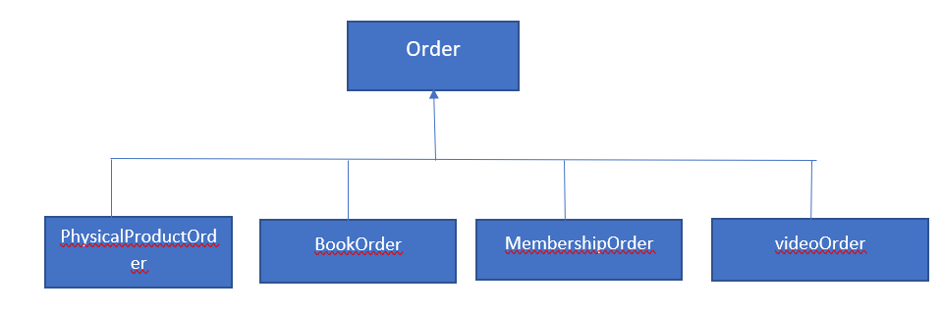

1. Rules that an order has to apply like Generating Packing slip, Activating membership, sending email, etc. can be created by implementing IOrderRule interface , which ensures that every rule has a method ApplyRule which performs specific task designated by the rule.

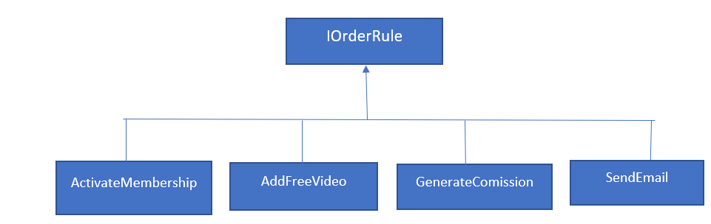

1. Order rules applicable to an order are specified in appsetting.json file. Any number of rules can be applied to an order by specifying the comma separated rules before the order category.

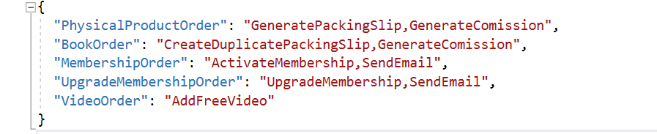

1. All the rules applicable to an order, as specified in the appsetting.json are read and Rule type is generated dynamically **using reflection** to call the ApplyRule method. Apply rule method performs task associated with the rule.
2. In this way, New order categories can be added to the system , new rules can be added to the system, exiting or new rules can be applied to new or existing order categories on demand by specifying rules applicable to an order in appsetting.json